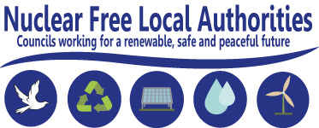

**NFLA English Forum - Summer Seminar**

**Friday 15th June, Long Room, Oxford Town Hall,**

**St Aldates, Oxford, OX1 1BX 10.30am – 1.30pm**

**Nuclear transports, nuclear transparency and delivering decentralised energy**

**A seminar for Councils and NGOs on issues of concern; and how Councils can play a major role in delivering low carbon energy**

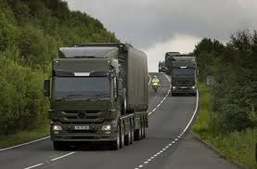

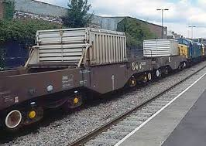

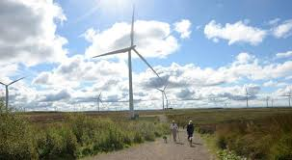

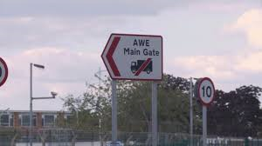

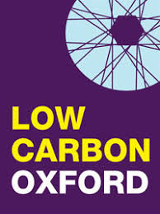

**Programme:**

10.30am Registration

11.00am Councillor John Tanner, Oxford City Council NFLA representative – **local welcome**

11.05am Councillor David Blackburn, NFLA English Forum Chair, Leeds City Council –

**Seminar introduction**

11.10am David McKenzie, Nukewatch Scotland and Nigel Day, Nukewatch England

**The Unready Scotland report - What information should Councils provide the public over the safety and risks of nuclear weapon road convoy transports?**

11.35am David Polden, Nuclear Trains Action Group

**What are the risks of civil nuclear transports in England?**

11.55am Dave Cullen, Nuclear Information Service (based in Reading)

**Censoring the Ministry of Defence's nuclear safety regulator - an end to public accountability on nuclear safety at defence sites?**

12.15pm Sean Morris, NFLA Secretary

**Delivering best practice in decentralised energy around the UK and Ireland**

12.35pm Paul Robinson, Team Manager, Energy & Natural Resources, Oxford City Council

**Oxford City Council’s progress on developing decentralised energy and district heating networks – a local case study**

12.55pm Councillor Sean Chaytor, NFLA English Forum Vice-Chair, Hull City Council

**Panel discussion and concluding comments**

1.30pm Seminar conclusion



**NFLA English Forum - Summer Seminar**

**Friday 15th June, Long Room, Oxford Town Hall,**

**St Aldates, Oxford, OX1 1BX 10.30am – 1.30pm**

**Nuclear transports, nuclear transparency and delivering decentralised energy**

**A seminar for Councils and NGOs on issues of concern; and how Councils can play a major role in delivering low carbon energy**

The seminar is a free event open to Councillors, Council Officers and peace / environmental NGOs and those interested in this subject matter. If you are planning to attend, could you please fill in the appropriate details and post or email to the address at the bottom of this form:

|  |  |  |
| --- | --- | --- |
| Name | Authority / Group | Correspondence address  (email or postal) |
|  |  |  |
|  |  |  |
|  |  |  |
|  |  |  |

**Venue and local details:**

Oxford Town Hall is situated in the centre of the City on St. Aldate's, a short walk from Gloucester Green bus station and Oxford Railway Station. Oxford has good connections to London and the rest of the country through Cross County Trains.

A map of the city locating the Town Hall can be downloaded from:

<https://www.oxfordtownhall.co.uk/townhall/homepage/11/find_us>

To locate car parks close to the Town Hall go to:

<https://www.oxford.gov.uk/info/20078/parking_in_oxford>

If you are looking for hotel accommodation please look at the Experience Oxford and Oxfordshire website: <https://www.experienceoxfordshire.org>

For further information, and to email a completed registration form, contact Sean Morris, Chapter Secretary – [s.morris4@manchester.gov.uk](mailto:s.morris4@manchester.gov.uk) or phone 00 44 (0)161 234 3244. Alternatively post to Policy Partnerships & Research, Level 3, Town Hall Extension, Library Walk, Manchester, M60 3NY.

This seminar is kindly hosted by Oxford City Council, members of Nuclear Free Local Authorities. The NFLA Secretariat would like to thank Councillor John Tanner, for hosting the meeting.