Women’s International League for Peace and Freedom
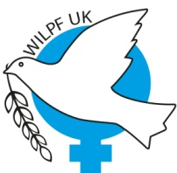
UK Section
52-54 Featherstone Street London EC1Y 8RT
020 7250 1968 ukwilpf.peace@gmail.com | www.wilpf.org.uk
Facebook.com/UKWILPF | Twitter @UKWILPF

Consultative Status with: United Nations ECOSOC, UNCTAD and UNESCO
Special Consultative Relations with: FAO, ILO and UNICEF

May 18th, 2018,

Dear Rt. Hon Boris Johnson MP
The UK Section of the Women’s International League for Peace and Freedom an organisation that has campaigned for peace, against the trade in arms and for human rights for 103 years requests that the United Kingdom Government:

- Condemns the action of the Israeli government towards the people of Gaza, especially the level of violence and the 59 deaths on Monday 15th May:

- Summon Mark Regev, the Israeli Ambassador, to condemn the use of live ammunition against children and unarmed protesters and urge greater restraint by the Israeli troops

- Continue to back the UN’s call for an independent investigation into the violence

- Launch a review of all weapons export licenses to Israel to ensure that British arms are not being used against children and unarmed protesters;

- Redouble efforts to end the 10-year blockade of Gaza which is causing so much harm to women and children especially.

Yours sincerely

Anne Scott, Secretary,

UK Section Women’s International League for Peace and Freedom

